Internship Project Report

EDGE-BASED SMART SUSPENSION SYSTEM

Jampani Rohith
GitHub/jampanirohith/Edge-Based-Smart-Suspension

ABSTRACT
This project develops a real-time edge-based system for detecting road surface anomalies — potholes and speed bumps — using a single monocular camera and a YOLOv8 object detection model. Upon detection, a ground-plane projection algorithm estimates the distance to each hazard, and a geometric risk metric quantifies its severity. Time-to-Impact (TTI) is calculated using the estimated distance and vehicle speed. A rule-based decision engine combines severity and urgency to produce suspension directives — NORMAL, PREPARE, or ADJUST NOW — before the vehicle reaches the obstacle. All processing runs locally on an edge device, removing the need for cloud infrastructure. The system offers a cost-effective alternative to the predictive suspension technologies found in premium vehicles.

TABLE OF CONTENTS

Section | Page
ABSTRACT | 2
CHAPTER 1: INTRODUCTION | 4
CHAPTER 2: LITERATURE REVIEW | 5
CHAPTER 3: SYSTEM ANALYSIS AND DESIGN | 6
CHAPTER 4: METHODOLOGY | 8
CHAPTER 5: IMPLEMENTATION | 10
CHAPTER 6: RESULTS AND DISCUSSION | 11
CHAPTER 7: CONCLUSION AND FUTURE SCOPE | 14
REFERENCES | 15
APPENDICES | 16

CHAPTER 1: INTRODUCTION

1.1 Background
Road irregularities such as potholes and speed bumps cause sudden suspension stress, accelerate mechanical wear, and reduce passenger comfort. Standard suspension systems only react after contact with a hazard — there is no warning or preparation beforehand.
Premium vehicles from BMW and Mercedes-Benz offer predictive suspension systems using cameras and radar, but these rely on expensive hardware that is out of reach for most vehicles. Recent advances in deep learning and edge computing make it possible to build a similar capability at a fraction of the cost using a single camera and a small compute device.

1.2 Problem Statement
Drivers encounter road anomalies with little to no warning, causing abrupt suspension impacts that contribute to component wear and passenger discomfort. Existing low-cost road monitoring solutions detect hazards but do not estimate distance, assess severity, or generate control directives — leaving a gap between detection and actionable suspension response.

1.3 Aim of the Project
To develop an edge-based computer vision framework that detects potholes and speed bumps in real time and generates predictive suspension adjustment commands before the vehicle reaches the obstacle.

1.4 Objectives
– Compile and annotate a dataset of pothole and speed bump images.
– Train a YOLOv8 object detection model to identify road anomalies.
– Implement real-time inference on local edge hardware.
– Estimate hazard distance using monocular ground-plane projection.
– Classify anomaly severity based on estimated physical width.
– Compute Time-to-Impact (TTI) using estimated distance and vehicle speed.
– Generate suspension directives (NORMAL / PREPARE / ADJUST NOW) using a rule-based decision engine.

1.5 Proposed Methodology
A forward-facing monocular camera streams road footage to a local edge device. A YOLOv8n model processes each frame to detect potholes and speed bumps. Ground-plane geometry converts pixel coordinates to metric distances. Physical width is derived from the bounding box and estimated distance to grade severity. TTI is calculated using the vehicle speed. A decision engine fuses these inputs to output a suspension directive per frame.

1.6 Scope of the Project
The project covers real-time road hazard detection, distance estimation, severity classification, and decision generation within an edge-computing environment. Physical suspension actuation, CAN bus integration, and embedded hardware deployment are out of scope for this internship phase and are reserved for future work.

CHAPTER 2: LITERATURE REVIEW

2.1 Existing Systems
Road condition monitoring has traditionally relied on manual inspection or vehicle-mounted sensors (accelerometers, gyroscopes) that detect anomalies reactively — only after the vehicle has hit the hazard. Premium automotive manufacturers have introduced camera and radar-based predictive suspension systems, but the sensor hardware and proprietary ECUs involved push costs well beyond the affordable range.
Deep learning-based object detection — particularly YOLO-family models — has made real-time, camera-based pothole and speed bump detection feasible on standard hardware. Edge computing platforms now provide the low latency needed for in-vehicle inference without cloud dependency.

2.2 Research Papers Survey
The primary reference for this project is SBP-YOLO (Liang et al., 2026) [1], which proposes a lightweight YOLOv11-based detector specifically for speed bumps and potholes to drive predictive suspension control. The model achieves 87% mAP at 139 FPS on an NVIDIA Jetson AGX Xavier. POT-YOLO (Bhavana et al., 2024) [2] achieves 97.6% precision on pothole classification using a YOLOv8-based edge architecture, validating the approach taken in this project.

2.3 Research Gap
Most published solutions focus solely on anomaly detection without integrating spatial estimation, severity grading, or suspension-oriented decision support. Many also depend on expensive sensors (LiDAR, stereo cameras) or cloud inference, which limits their practical applicability. This project addresses the gap by combining detection, distance estimation, severity assessment, TTI computation, and decision generation in a single monocular edge-based pipeline — without cloud dependency or expensive sensors.

CHAPTER 3: SYSTEM ANALYSIS AND DESIGN

3.1 Proposed System
The proposed system processes live road footage from a forward-facing camera through a sequential pipeline: YOLOv8n detection, ground-plane distance estimation, severity classification, TTI computation, and a rule-based decision engine. All computation runs locally on an edge device. The outputs are an annotated video, a structured CSV log, and a per-frame suspension directive.

3.2 System Architecture
The system is organised into two functional stages. The perception stage handles frame acquisition, object detection, hazard localisation, and distance estimation. The decision stage covers severity assessment, TTI calculation, decision fusion, and output generation. Figure 3.1 illustrates the full module-level architecture.

Road Environment
Input
↓
PERCEPTION STAGE
Forward-Facing Camera
Monocular image sensor
↓
Video Acquisition Module
Frame digitisation
↓
YOLOv8 Detection Engine
Convolutional inference
↓
Hazard Localisation
Bounding-box regression
↓
Distance Estimation Module
Ground-plane projection
↓
DECISION STAGE
Severity Assessment Module
Lateral-extent stratification
↓
Time-to-Impact Computation
Kinematic scheduling
↓
Decision Engine
Rule-based fusion
↓
Suspension Directive
Actuation command
↓
Video Output & Analytics Log
Output
Fig. 3.1. Module-level architecture of the perception-to-actuation pipeline.

3.3 Data Flow
Table 3.1. Stage-wise data-flow pipeline.
Stage | Designation | Description
1 | Data Acquisition | Camera captures road scene; OpenCV extracts frames sequentially.
2 | Hazard Detection | YOLOv8n returns bounding boxes, class labels, and confidence scores.
3 | Spatial Estimation | Bottom edge of bounding box is projected onto the ground plane to estimate range.
4 | Severity Analysis | Physical width is derived from box dimensions and range; severity is classified.
5 | Impact Assessment | TTI is computed from estimated distance and vehicle speed.
6 | Decision Generation | Severity and urgency are fused to produce the suspension directive.
7 | Output | Annotated frames are written to video; per-frame records are appended to CSV.

3.4 System Requirements

3.4.1 Hardware Requirements
Table 3.2. Hardware configuration used in the experiment.
Component | Specification | Role
Vehicle-Mounted Camera | Smartphone camera (dashboard mount) | Records forward road footage for system input
Video Transfer | USB cable / microSD card transfer | Transfers footage from camera to compute device
Compute Device | Laptop — NVIDIA GeForce RTX 5050 GPU (CUDA 12.8) | Runs all inference and decision logic
Local Storage | SSD | Stores dataset, model weights, output video, CSV logs

Note: A live wireless video link was not used in this phase. The system was tested on pre-recorded footage. Network streaming is planned for the next phase.

3.4.2 Software Requirements
Table 3.3. Software environment.
Tool / Library | Purpose
Python 3.11 | Primary programming language
PyTorch (CUDA 12.8 nightly) | Deep learning backend — required for RTX 5050
Ultralytics YOLOv8 | Object detection model and training framework
OpenCV 4.10.0 | Video capture, frame processing, annotation, output encoding
Roboflow | Dataset management, annotation, augmentation, YOLO-format export
NumPy / Pandas / CSV | Post-processing and analytical logging
VS Code / Jupyter | Development environment

3.5 Environment Set-Up
The following procedure was used to configure the development environment on Windows 11. The RTX 5050 Laptop GPU requires a CUDA 12.8 nightly build of PyTorch — standard stable builds do not support this GPU.

# Create and activate virtual environment
py -3.11 -m venv suspension_env
.\suspension_env\Scripts\Activate

# Install GPU-enabled PyTorch (RTX 5050 requires CUDA 12.8 nightly)
pip install --pre torch torchvision torchaudio --index-url https://download.pytorch.org/whl/nightly/cu128

# Install remaining dependencies
pip install ultralytics opencv-python==4.10.0.84 roboflow pandas numpy

# Verify GPU
python -c "import torch; print(torch.cuda.is_available(), torch.cuda.get_device_name(0))"
# Expected: True NVIDIA GeForce RTX 5050 Laptop GPU
Listing 3.1. Environment configuration and dependency installation.

CHAPTER 4: METHODOLOGY

4.1 System Workflow
Each video frame passes through the complete pipeline sequentially: detection, spatial estimation, severity and TTI computation, decision fusion, and output. Figure 4.1 shows the detailed flowchart including all conditional branches and decision outcomes (NORMAL, PREPARE, ADJUST NOW).

START
↓
STAGE 1 — DATA ACQUISITION
Capture Video Frame
OpenCV VideoCapture
↓
Preprocess Frame
model.predict() — internally resized to 640 × 640, normalised
↓
STAGE 2 — HAZARD DETECTION
Run YOLOv8 Inference
Confidence threshold τ = 0.50; detects potholes and speed bumps
↓
Road Anomaly Detected?
Were any bounding boxes returned above the confidence threshold?
↓
↓ ↓
NO  Skip to next frame | YES  Continue to extraction for each detected bounding box
↓
STAGE 3 — SPATIAL ESTIMATION
Extract Bounding Box Coordinates
Retrieve pixel coordinates (x1, y1, x2, y2) and Confidence score
↓
Estimate Distance via Ground-Plane Projection
d = h / tan(θ + arctan((y₂ − cᵧ) / f))
↓
Valid Distance Computable?
total_angle > 0 and distance result is not None
↓
↓ ↓
INVALID  Skip this detection | VALID  Proceed to width and risk computation

↓
Calculate Physical Width of Anomaly
w = (bbox_widthₚᵪ × d) / f Represents the estimated real-world lateral extent of the detected anomaly
↓
Compute Distance-Normalised Risk Score
R = w / max(d, 1) Normalises anomaly size relative to longitudinal distance
↓
STAGE 4 — SEVERITY ASSESSMENT
Severity Classification
Stratify R against empirical thresholds
↓
↓ ↓ ↓
R < 0.08  ↓  LOW  Minor anomaly | 0.08 ≤ R < 0.18  ↓  MEDIUM  Moderate anomaly | R ≥ 0.18  ↓  HIGH  Severe anomaly
↓
STAGE 5 — TIME-TO-IMPACT ASSESSMENT
Compute Time-To-Impact (TTI)
TTI = d / v
↓
Urgency Classification
↓
↓ ↓ ↓
TTI > 3.0 s  ↓  LOW URGENCY  Adequate margin | 1.5 < TTI ≤ 3.0 s  ↓  MEDIUM URGENCY  Reduced margin | TTI ≤ 1.5 s  ↓  HIGH URGENCY  Imminent contact
↓
STAGE 6 — DECISION ENGINE (SEVERITY × URGENCY MATRIX)
Generate Suspension Directive
Rule-based fusion of severity and urgency classifications
↓
↓ ↓ ↓
Urgency = High  AND  Severity = High  ↓  ADJUST NOW  Immediate suspension  adjustment required | Urgency = High + Severity = Medium  OR  Urgency = Medium + Severity = High  ↓  PREPARE  Prepare suspension for  imminent adjustment | All other  Severity × Urgency  combinations  ↓  NORMAL  No suspension action;  continue monitoring
↓
STAGE 7 — OUTPUT GENERATION
Annotate Frame with Detection Overlay
Draw bounding box | Display: R (risk score), D (distance), W (width), S (severity), TTI, urgency, directive
↓
Write Detection Record to CSV Analytical Log
Appends row: frame, confidence, distance_m, real_width_m, risk_score, severity, tti_s, urgency
↓
Write Annotated Frame to Output Video
cv2.VideoWriter encodes frame to output.mp4 at source FPS
↓
Display Frame in Real-Time Preview Window
cv2.imshow renders annotated frame; non-blocking waitKey(1)
↓
Continue Processing?
End of video stream reached, or user pressed 'Q'

Q PRESSED / END  ↓  Release resources  cap.release() | out.release() | csv.close() | CONTINUE ↑  Capture next frame  ↑ Loop back to top

↓
END — Session Complete
Fig. 4.1. Complete system workflow with all decision branches.

4.2 Dataset Preparation
A unified dataset was assembled from publicly available pothole and speed bump repositories on Roboflow. Images were annotated with bounding boxes in YOLO format. Two classes were defined: Class 0 — Pothole, Class 1 — Speed Bump. The dataset was split 70% training / 11% validation / 19% testing.

4.3 Object Detection Module
The YOLOv8n (nano) model was selected for its low parameter count (3.2M) and fast inference. Transfer learning from COCO pre-trained weights was used to improve convergence speed and generalisation across varied road conditions. For each detected anomaly, the model returns bounding box coordinates (x₁, y₁, x₂, y₂), the class label, and a confidence score.

4.4 Distance Estimation Module
Longitudinal distance is estimated by back-projecting the lower bounding-box edge onto a planar ground model using the camera’s extrinsic parameters — mounting height H and pitch angle α:
D = H / tan(θ), where θ = |α| + arctan ((y₂ − cᵧ) / fₓ)
H = 1.20 m (camera height), α = 8.0° (pitch), cᵧ = image vertical centre, fₓ = focal length in pixels.
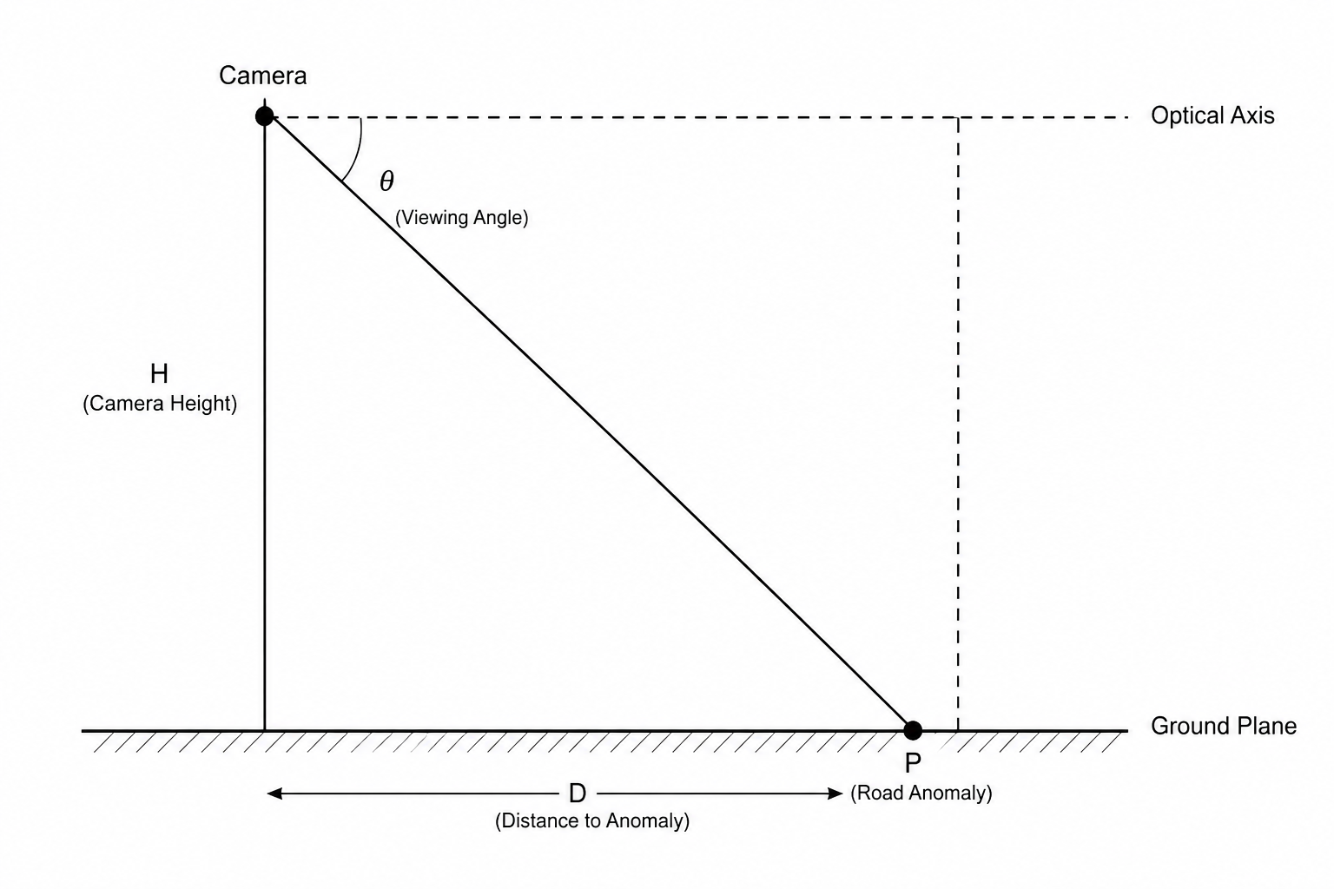
Fig. 4.4.1. Ground-plane perspective projection model.

4.5 Severity Assessment Module
Physical width of the anomaly is estimated from the pixel-domain bounding-box width and the estimated distance:
W = (Wₚᵪ × D) / fₓ
W is then normalised by distance to give a risk score R = W / max(D, 1), and mapped to three severity levels:
Table 4.5.1. Structural anomaly severity classification.
Real-World Width (W) | Severity | Implication
< 0.5 m | Low | Minor defect; minimal chassis impact
0.5 m – 1.0 m | Medium | Moderate anomaly; damping adjustment recommended
> 1.0 m | High | Large defect; immediate suspension response required

4.6 Time-To-Impact Analysis
TTI is the time remaining before the front wheel contacts the detected hazard:
TTI = D / V, where V = vₖₘ/ₕ / 3.6
TTI is then mapped to an urgency level to prioritise the control response:
Table 4.6.1. TTI urgency classification.
TTI Threshold | Urgency Level | System Implication
> 2 s | Low | Sufficient time; monitor only
1 – 2 s | Medium | Hazard approaching; prepare suspension
< 1 s | High | Imminent; actuate immediately

4.7 Decision Engine
The decision engine cross-references severity and urgency to generate the suspension directive:
Table 4.7.1. Suspension decision matrix.
Urgency | Severity | Directive
High | High | ADJUST NOW — immediate damping modulation
High | Medium | PREPARE — prime suspension for adjustment
Medium | High | PREPARE — begin adjustment sequence
Any other combination | — | NORMAL — continue monitoring

4.8 Model Training
The YOLOv8n model was fine-tuned over 30 epochs on the compiled dataset using the configuration in Table 4.8.1.
Table 4.8.1. Training configuration.
Parameter | Value
Base architecture | YOLOv8n (3.2M parameters)
Initialisation | COCO pre-trained weights
Epochs | 30
Batch size | 16
Input resolution | 640 × 640
Optimiser | AdamW (lr₀ = 0.001)
Confidence threshold | 0.50
Augmentation | Horizontal flip, HSV brightness, Mosaic

CHAPTER 5: IMPLEMENTATION
The system is implemented as a single Python script (main.py) that runs all modules in sequence for each video frame. Key code snippets for each module are shown below; full listings are in Appendix C.

5.1 Video Acquisition
cap = cv2.VideoCapture(video_path)
ret, frame = cap.read()
Code Snippet 5.1.1. Frame extraction using OpenCV VideoCapture.

5.2 Object Detection
model = YOLO('best.pt')
results = model.predict(frame, conf=0.5, verbose=False)
Code Snippet 5.2.1. YOLOv8n model load and inference.

5.3 Distance Estimation
distance = estimate_distance_groundplane(
y_bottom=y2, image_height=frame.shape[0], focal_px=FOCAL_PX)
Code Snippet 5.3.1. Ground-plane distance calculation call.

5.4 Severity Assessment
real_width = (bbox_width * distance) / FOCAL_PX
risk_score = real_width / max(distance, 1)
if risk_score < 0.08: severity = 'Low'
elif risk_score < 0.18: severity = 'Medium'
else: severity = 'High'
Code Snippet 5.4.1. Width estimation and severity classification.

5.5 Time-To-Impact Analysis
tti = distance / (SPEED_KMH / 3.6)
urgency = 'High' if tti < 1.5 else 'Medium' if tti < 3.0 else 'Low'
Code Snippet 5.5.1. TTI computation.

5.6 Decision Engine
if urgency == 'High' and severity == 'High': decision = 'ADJUST NOW'
elif urgency in ('High','Medium') and severity in ('High','Medium'):
decision = 'PREPARE'
else: decision = 'NORMAL'
Code Snippet 5.6.1. Rule-based decision engine.

5.7 Output Generation
out.write(annotated_frame) # annotated video
writer.writerow([frame_id, cls, distance, width, severity, tti, decision]) # CSV
Code Snippet 5.7.1. Output video writing and CSV logging.

CHAPTER 6: RESULTS AND DISCUSSION

6.1 Experimental Setup
The system was tested on a pre-recorded road video within a software-in-the-loop (SIL) setup. Table 6.1 documents the hardware, software, and camera calibration parameters.
Table 6.1. Experimental environment and sensor calibration.
System Attribute | Value
Hardware
GPU | NVIDIA GeForce RTX 5050 Laptop GPU (CUDA 12.8)
RAM | 16 GB DDR5
Software
Framework | Python 3.11 / PyTorch (nightly) / Ultralytics YOLOv8
Vision Library | OpenCV 4.10.0
Camera Calibration
Mounting Height (H) | 1.20 m
Focal Length (fₓ) | 650.0 px
Pitch Angle (α) | 8.0° downward
Input Resolution | 1280 × 720 (processed at 640 × 640)

6.2 Dataset Statistics
Table 6.2. Dataset split.
Partition | Images
Training | 3046
Validation | 468
Total | 3514

6.3 Training Convergence
The model was fine-tuned for 30 epochs. Loss curves showed steady convergence without overfitting. Final validation metrics are in Table 6.3.
Table 6.3. Validation metrics.
Metric | Value
Precision | 0.798
Recall | 0.644
mAP@50 | 0.731
mAP@50–95 | 0.415
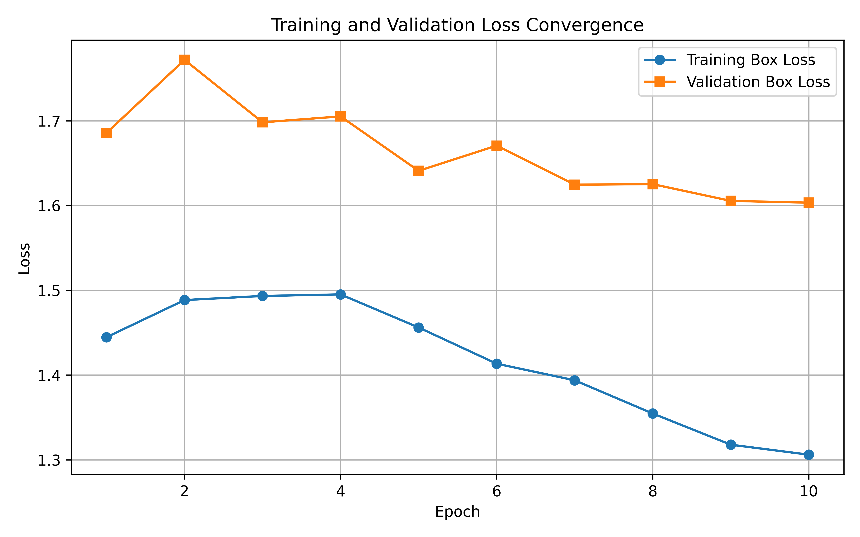
Fig. 6.1. Training and validation loss convergence over 30 epochs.

6.4 Class-Wise Performance
Table 6.4. Per-class detection performance.
Class | Precision | Recall | mAP@50 | mAP@50–95
Speed Bump | 0.904 | 0.745 | 0.852 | 0.503
Pothole | 0.692 | 0.543 | 0.610 | 0.326
Speed bumps achieved higher accuracy due to their consistent geometry and painted markings. Potholes vary significantly in shape, size, and surface texture, making feature extraction harder.
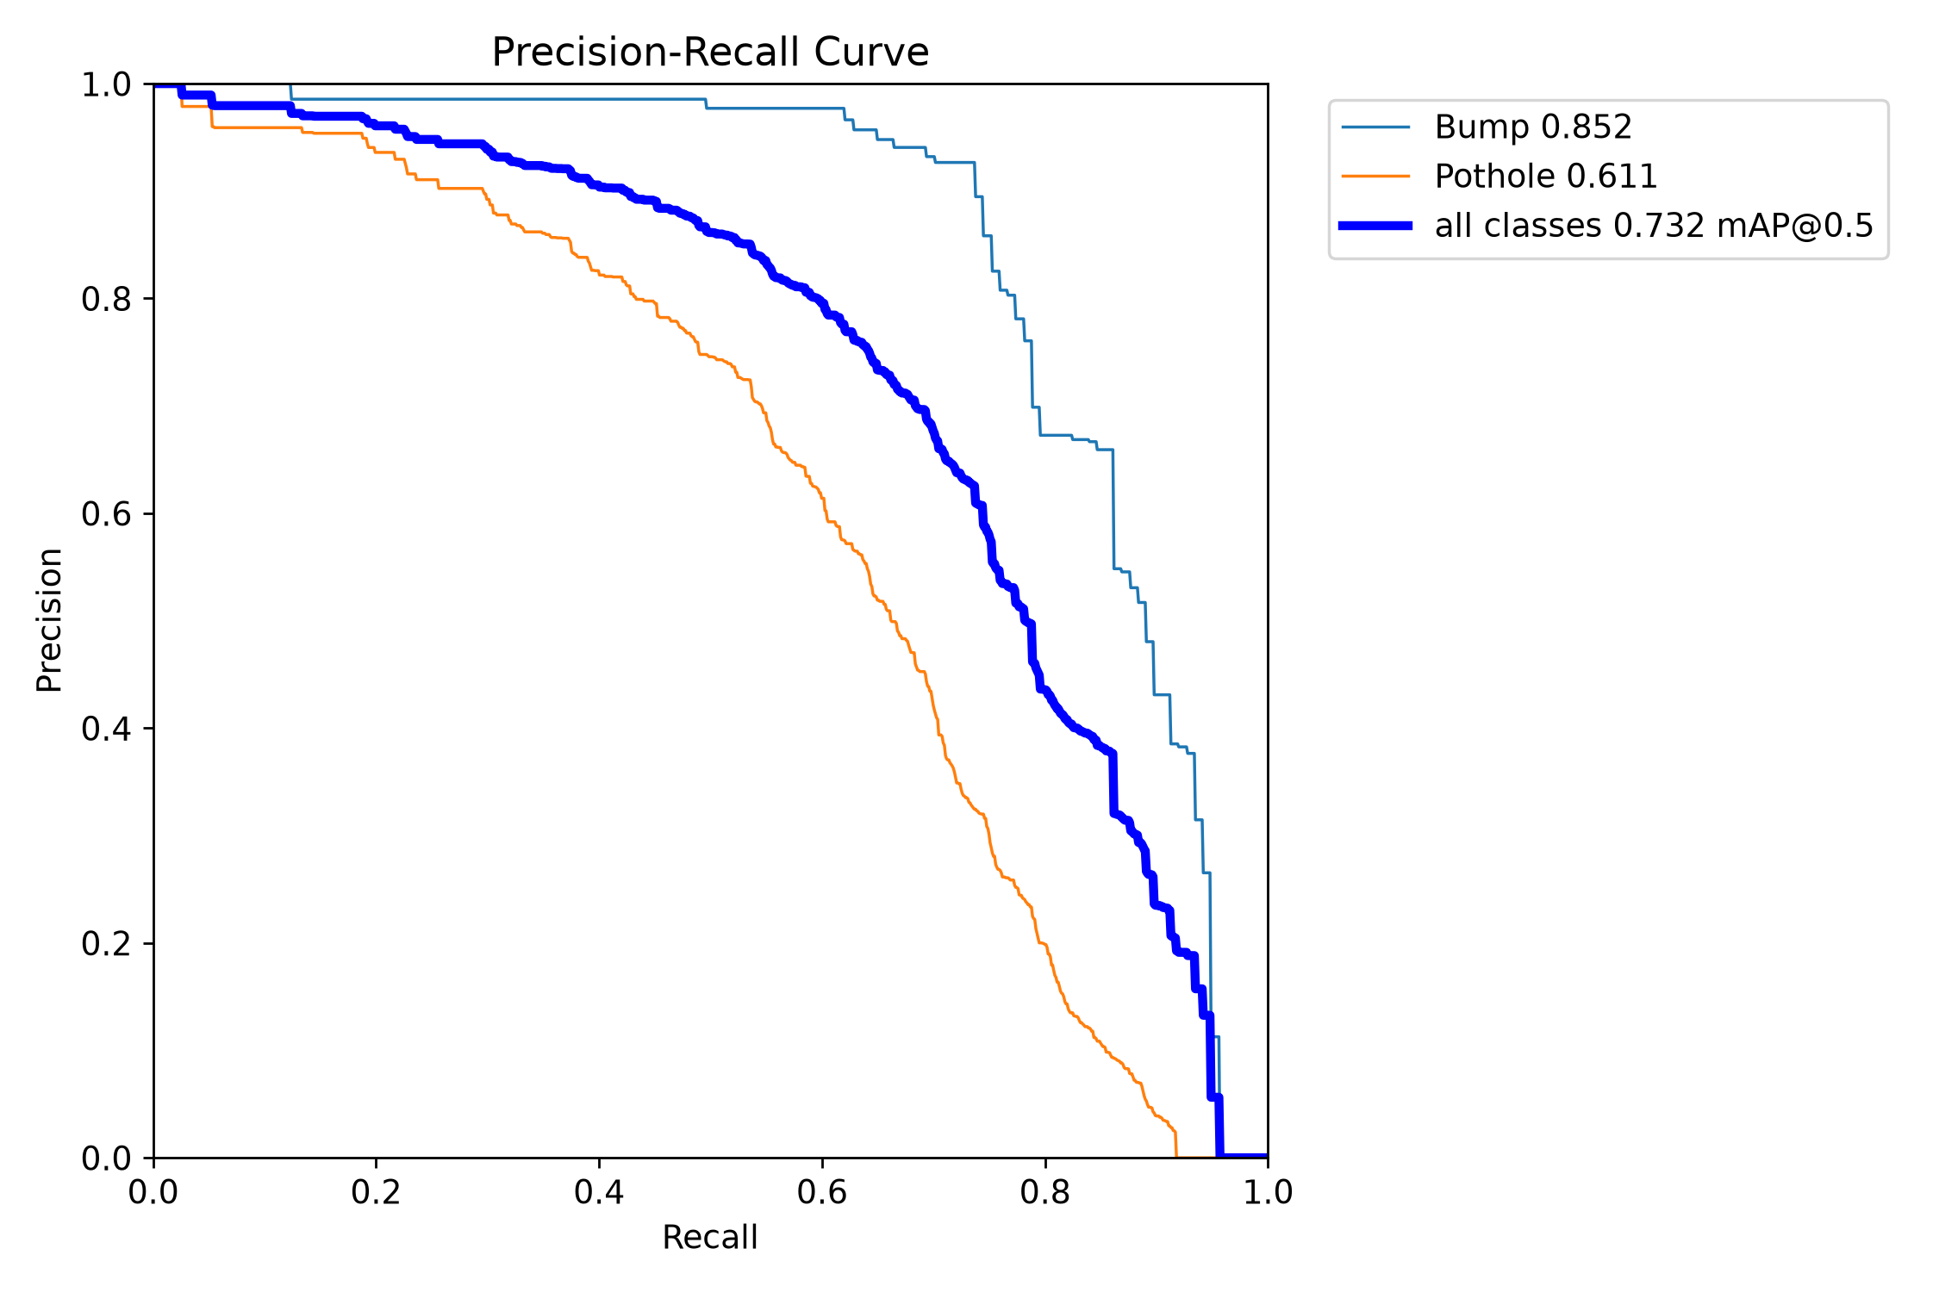
Fig. 6.2. PR convergence curve for the trained model.
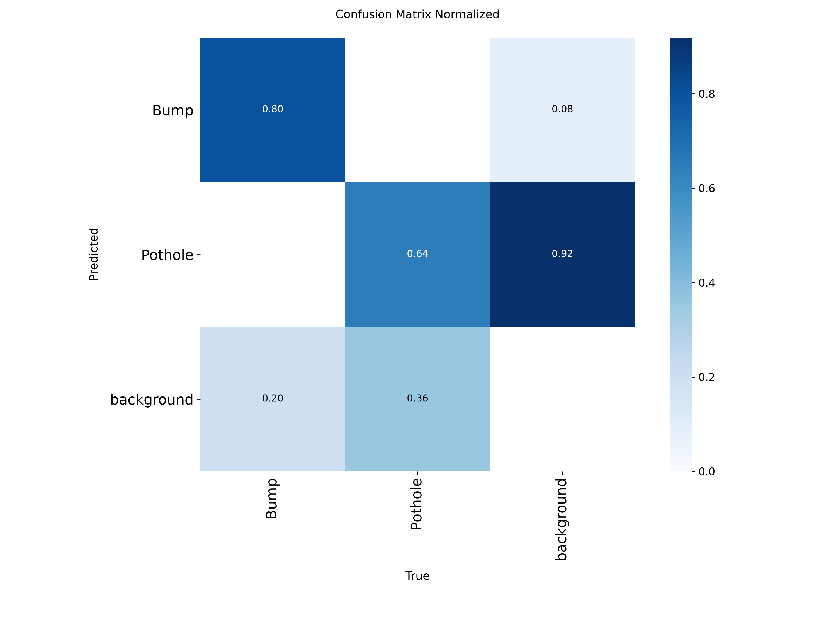
Fig. 6.3. Validation confusion matrix.

6.5 Detection Results
The model detected both anomaly classes reliably across the evaluation sequence:
– Real-time localisation of potholes and speed bumps across the full camera field of view.
– Simultaneous multi-object detection within a single frame.
– No frame drops at the target inference rate.
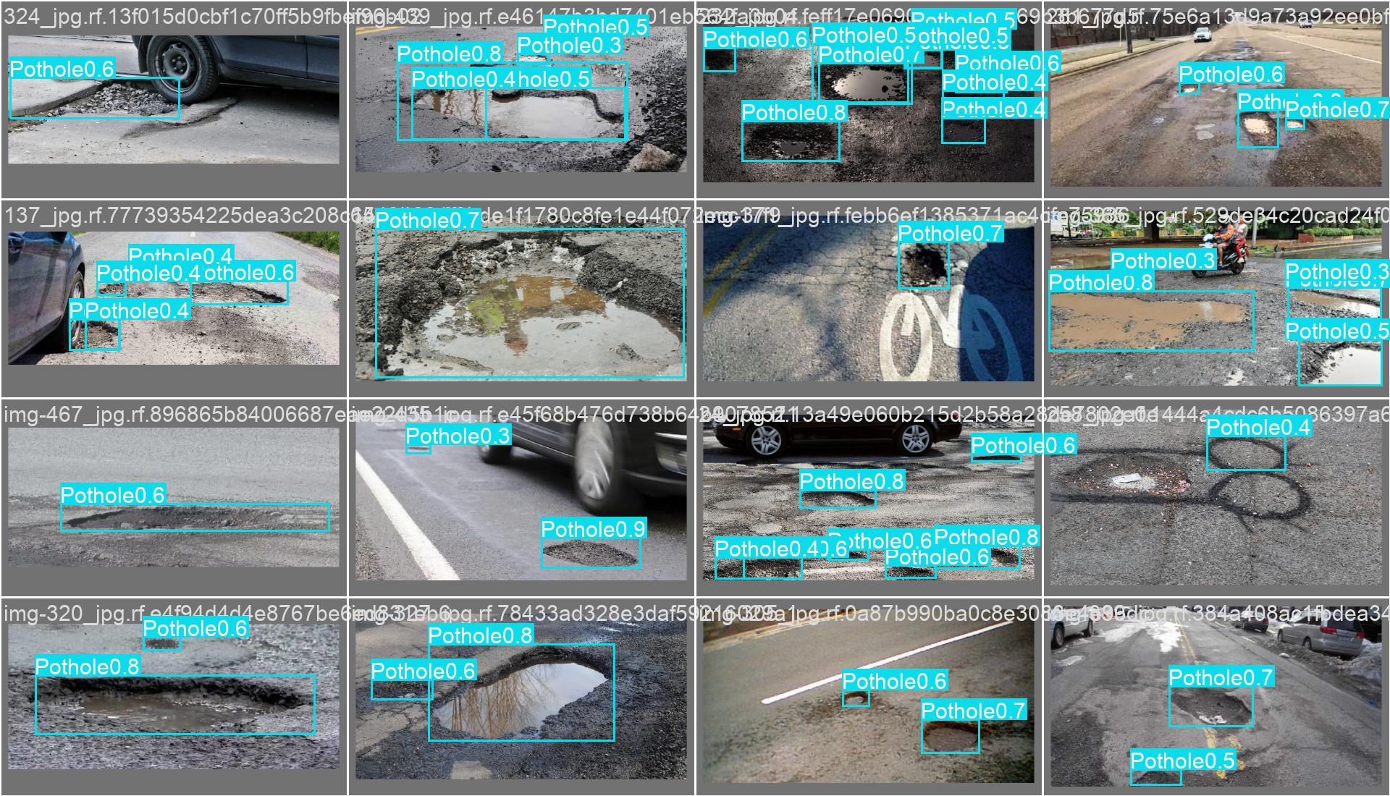
Fig. 6.4. Output frame showing pothole bounding box and confidence score.
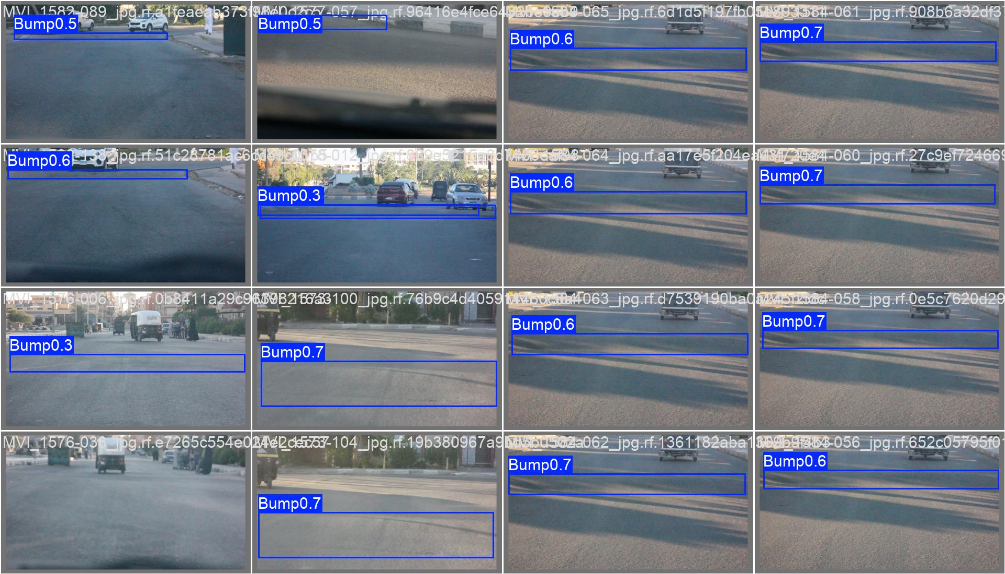
Fig. 6.5. Output frame showing speed bump detection.

6.6 Distance Estimation Results
Table 6.5. Sample distance estimation outputs.
Detection | Estimated Distance
Pothole A | 2.8 m
Pothole B | 4.5 m
Speed Bump A | 6.2 m
Speed Bump B | 8.7 m

6.7 Severity Assessment Results
Table 6.6. Sample severity outputs.
Distance | Width (W) | Severity
3.2 m | 0.34 m | Low
4.5 m | 1.25 m | Medium
6.8 m | 3.45 m | High

6.8 Time-to-Impact Analysis
Table 6.7. TTI at 40 km/h.
Distance | Computed TTI
5 m | 0.45 s
10 m | 0.90 s
15 m | 1.35 s
20 m | 1.80 s

6.9 Suspension Decision Results
Table 6.8. Sample decision engine outputs.
Severity | TTI | Directive
Low | 2.5 s | NORMAL
Medium | 1.4 s | PREPARE
High | 0.7 s | ADJUST NOW
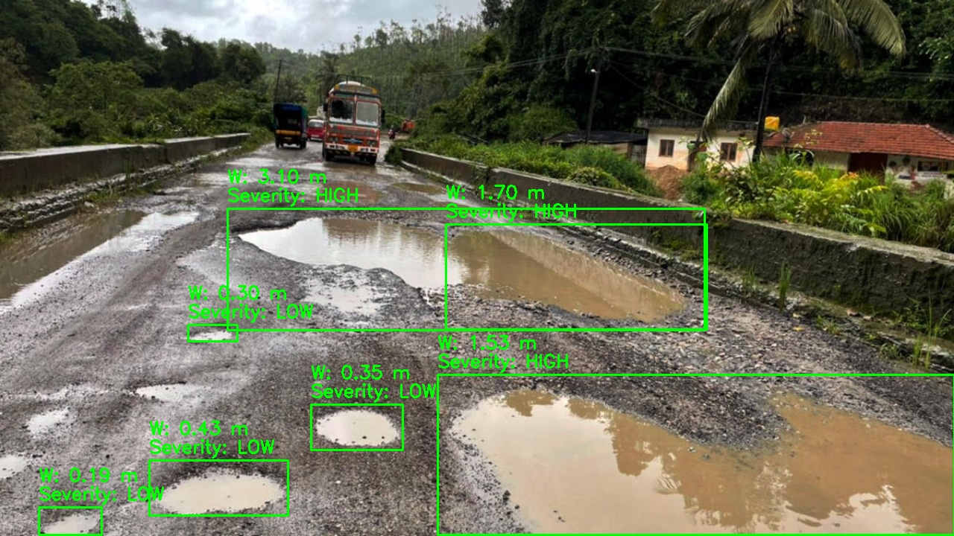
Fig. 6.7. Severity assessment and directive overlay on a sample frame.

6.10 Runtime Logs
Table 6.9. Sample CSV log output.
Frame | Class | Dist. (m) | Width (m) | Severity | Speed (kph) | TTI (s) | Directive
1042 | None | N/A | N/A | N/A | 45.0 | N/A | NORMAL
1043 | Pothole | 18.5 | 0.85 | Medium | 45.0 | 1.48 | PREPARE
1044 | Pothole | 12.2 | 0.88 | Medium | 45.0 | 0.97 | ADJUST NOW

[DEBUG] Frame 1043: Pothole | Conf=0.82 | Dist=18.5m | Width=0.85m | Sev=Medium
[CALC] TTI = 18.5 / 12.5 = 1.48s -> Urgency: Medium
[ACTION] Directive: PREPARE

[DEBUG] Frame 1044: Pothole | Conf=0.86 | Dist=12.2m | Width=0.88m | Sev=Medium
[CALC] TTI = 12.2 / 12.5 = 0.97s -> Urgency: High
[ACTION] Directive: ADJUST NOW
Console execution trace (abbreviated).

6.11 Computational Throughput
Table 6.10. Pipeline processing performance.
Metric | Value
Inference latency | 1.2 ms / frame
Post-processing (TTI / severity) | 0.9 ms / frame
Total pipeline latency | ~2.1 ms / frame
Sustained throughput | > 45 FPS
External network dependency | None

6.12 Discussion
The pipeline ran at over 45 FPS with a total per-frame latency of ~2.1 ms, well within the real-time requirements for automotive applications. The YOLOv8n model detected both road anomaly classes reliably across the test sequence, and the downstream distance, severity, and TTI modules produced consistent outputs frame by frame.
The main limitation is that the ground-plane distance model assumes a flat road and fixed camera orientation. In practice, road gradients or camera vibration will introduce error into the estimated distances, which then propagates into the severity and TTI calculations.
The fixed vehicle speed of 40 km/h is another constraint — in a real deployment, live speed data from GPS or the vehicle CAN bus would be needed. Despite these limitations, the system demonstrates a working proof-of-concept for vision-guided predictive suspension control on standard laptop hardware.

CHAPTER 7: CONCLUSION AND FUTURE SCOPE

7.1 Conclusion
This internship project built and validated a complete edge-based pipeline for predictive vehicle suspension control. Using a single monocular camera and YOLOv8n, the system detects potholes and speed bumps, estimates their distance and physical severity, computes time-to-impact, and generates suspension directives in real time. Key outcomes:

– YOLOv8n fine-tuned on 3,514 images — mAP@50: 0.731, Precision: 0.798, Recall: 0.644.
– Ground-plane projection estimates distance using only camera height and pitch angle.
– Risk-score metric classifies hazard severity as Low, Medium, or High.
– TTI computed per frame using estimated distance and fixed vehicle speed (40 km/h).
– Rule-based decision engine outputs NORMAL / PREPARE / ADJUST NOW.
– Pipeline sustains > 45 FPS with ~2.1 ms total latency per frame on RTX 5050.
– Fully local execution — no cloud dependency or network required.

The system provides a cost-effective, software-validated starting point for integrating predictive suspension control into standard vehicles.

7.2 Limitations
– Distance estimation assumes a flat road surface and fixed camera orientation — deviations cause error.
– Monocular vision cannot directly measure pothole depth.
– Vehicle speed is hardcoded at 40 km/h; no live speed input is integrated.
– Decision logic uses fixed thresholds and does not adapt to varying road materials or vehicle load.
– Validation was performed on pre-recorded video only — no physical actuation was tested.
– Detection accuracy drops under rain, low light, or camera contamination.

7.3 Future Scope
– Depth Estimation: Integrate Depth Anything or MiDaS for per-pixel depth from a single camera.
– Embedded Deployment: Deploy on NVIDIA Jetson Orin Nano or Raspberry Pi with Hailo-8L accelerator.
– Suspension Hardware: Translate directives into PWM signals for electronically controlled dampers.
– CAN Bus Integration: Read live speed, steering angle, and load from vehicle ECUs.
– Multi-Sensor Fusion: Combine camera with IMU (for pitch compensation) and LiDAR.
– Adaptive Control: Replace fixed-threshold decision logic with a reinforcement-learning policy.
– Simulation: Validate actuation strategies in MATLAB/Simulink or Unreal Engine before real-world testing.
– Live Streaming: Implement 5G/Wi-Fi video link to a shared edge server for multi-vehicle deployment.

REFERENCES
[1] C. Liang, J. Yuan, L. Gou, L. Luo, J. Fu, and M. Yu, “SBP-YOLO: A lightweight real-time model for detecting speed bumps and potholes toward intelligent vehicle suspension systems,” Journal of Real-Time Image Processing, vol. 23, no. 52, 2026.
[2] G. Jocher et al., “Ultralytics YOLOv8,” 2023. [Online]. Available: https://github.com/ultralytics/ultralytics
[3] Ultralytics, “YOLOv8 Documentation,” 2023. [Online]. Available: https://docs.ultralytics.com
[4] Roboflow, “Potholes-Bumps Dataset,” 2024. [Online]. Available: https://universe.roboflow.com/jampanis-workspace/potholesbumps
[5] OpenCV, “Camera calibration and 3D reconstruction,” 2024. [Online]. Available: https://docs.opencv.org/4.x/d9/d0c

APPENDICES

Appendix A — Dataset Samples
Representative annotated training images from the Roboflow corpus.
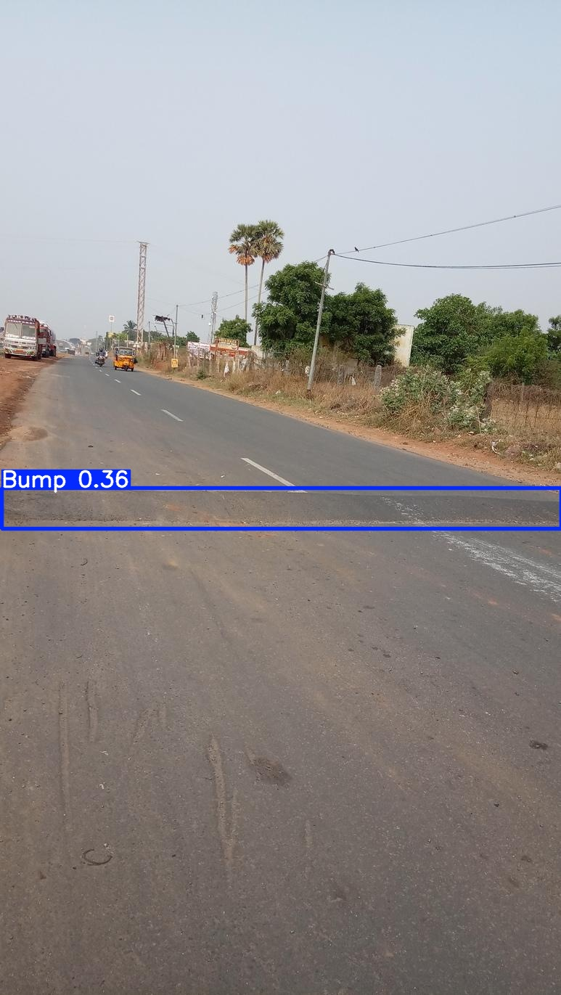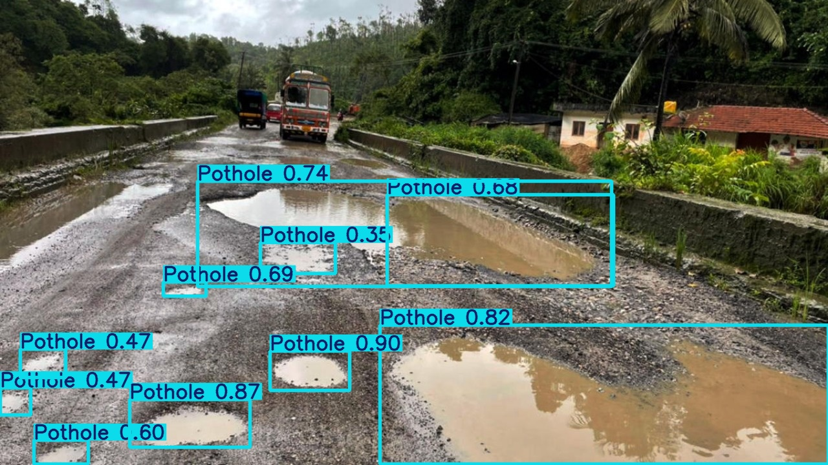
Annotated sample — Speed Bump class. Annotated sample — Pothole class.

Appendix B — Model Training Configuration
Table B.1. YOLOv8n training hyperparameters.
Parameter | Value | Notes
Base architecture | YOLOv8n | Nano variant; 3.2M parameters
Initialisation | COCO pre-trained | Transfer learning (yolov8n.pt)
Epochs | 30 | Early stopping on validation plateau
Batch size | 16 | Adjusted for VRAM
Input resolution | 640 × 640 | Standard YOLO resolution
Optimiser | AdamW | lr₀ = 0.001, weight decay = 5×10⁻⁴
Confidence threshold | 0.50 | Inference-time filter
NMS IOU threshold | 0.45 | Duplicate suppression limit
Augmentation | Flip 0.5, HSV 0.4, Mosaic | Applied during training
Workers | 0 (Windows) | Prevents multiprocessing deadlock

Appendix C — Source Code Listings

Listing C.1 — Ground-Plane Distance Estimation
def estimate_distance_groundplane(y_bottom, image_height, focal_px):
pitch_rad = math.radians(PITCH_DEG) # PITCH_DEG = 8.0
cy = image_height / 2
angle_rad = math.atan((y_bottom - cy) / focal_px)
total_angle = pitch_rad + angle_rad
if total_angle <= 0: return None
return round(CAMERA_HEIGHT_M / math.tan(total_angle), 2)
Listing C.1. Ground-plane projection function (main.py).

Listing C.2 — Severity Classification
def classify_severity(bbox_width_px, distance_m, focal_px):
real_width = (bbox_width_px * distance_m) / focal_px
risk_score = real_width / max(distance_m, 1)
if risk_score < 0.08: return real_width, risk_score, 'Low'
elif risk_score < 0.18: return real_width, risk_score, 'Medium'
else: return real_width, risk_score, 'High'
Listing C.2. Width estimation and severity classification (main.py).

Listing C.3 — TTI Computation
def compute_tti(distance_m, speed_kmh=40):
speed_mps = speed_kmh / 3.6
tti_s = distance_m / speed_mps
if tti_s > 3.0: urgency = 'Low'
elif tti_s > 1.5: urgency = 'Medium'
else: urgency = 'High'
return round(tti_s, 2), urgency
Listing C.3. Time-to-impact computation (main.py).

Listing C.4 — Decision Engine
def generate_directive(severity, urgency):
if urgency == 'High' and severity == 'High': return 'ADJUST NOW'
elif urgency == 'High' and severity == 'Medium': return 'PREPARE'
elif urgency == 'Medium' and severity == 'High': return 'PREPARE'
else: return 'NORMAL'
Listing C.4. Rule-based decision engine (main.py).

Appendix D — Experimental Outputs
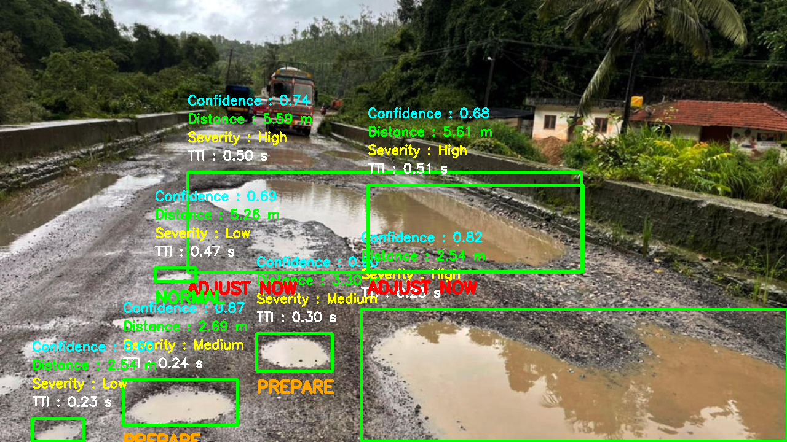
Fig. D.1. Pothole detection with bounding box, distance, severity and directive overlay.

Table D.1. Extended CSV log sample.
Frame | Class | Dist. (m) | Width (m) | Severity | Speed (kph) | TTI (s) | Directive
1042 | None | N/A | N/A | N/A | 45.0 | N/A | NORMAL
1043 | Pothole | 18.5 | 0.85 | Medium | 45.0 | 1.48 | PREPARE
1044 | Pothole | 12.2 | 0.88 | Medium | 45.0 | 0.97 | ADJUST NOW
1045 | Speed Bump | 9.3 | 1.42 | High | 45.0 | 0.74 | ADJUST NOW
1046 | None | N/A | N/A | N/A | 45.0 | N/A | NORMAL

